# Introduction to Computer Systems – COM402

# Time-Constrained Assignment

Student Name:…………………………………………… Student Id:…………………………….. Date:……………………

Formulas

Ohm’s Law V = IR Resistors in series RT = R1 + R2 + …… Rn

Impedance XC = 1/(2πfC) Resistors in parallel 1/RT = 1/R1 + 1/R2 + ….. 1/Rn

XL = 2πfL Power = VI

VBE = 0.7V

**You would need to highlight/Tick the right option for each question.**

1. In any number system the maximum value of a single digit is related to the base number as
2. One more than the value of the base
3. One less than the value of the base
4. Same as the value of the base
5. Two times the value of the base
6. What is the minimum number of bits required to represent a hexadecimal number?
7. 2
8. 3
9. 4
10. 8
11. Convert 1010112 into decimal?
12. 43
13. 39
14. 83
15. 51
16. Convert 2118 into decimal?
17. 512
18. 131
19. 128
20. 137
21. What is the resistance of a series circuit that allows a current of 40 mA to flow, when a voltage of 15 V is applied to the circuit?
22. 375 Ω
23. 600 Ω
24. 375 kΩ
25. 0.6 Ω
26. The circuit shown below is made up of a mixture of series and parallel combinations; calculate the total resistance?
    1. 243 Ω
    2. 1.15 kΩ
    3. 280 Ω
    4. 310 Ω



1. An EMF (Electro Magnetic Force) source (Volts) causes a current of 35 mA to flow in a circuit of resistance 240 Ω. What is the voltage of the EMF source?
2. 84 mV
3. 840 mV
4. 8.4 V
5. 84 V
6. Calculate the effective resistance of the following combination

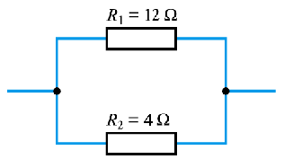

* 1. 6 Ω
  2. 3 Ω
  3. 16 Ω
  4. 8 Ω

1. The unit of frequency is
   1. Radian
   2. Hertz
   3. Lambda
   4. Watts
2. What is the impedance of a 30 mH inductor at 150 Hz?
   1. 35 mΩ
   2. 2.83 Ω
   3. 350 mΩ
   4. 28.3 Ω
3. What is the impedance of a 4.7 µF capacitor at 1 kHz?
   1. 339 Ω
   2. 34 Ω
   3. 3.4 Ω
   4. 339 mΩ
4. A component which resists changes in electric current passing through it is called
   1. Diode
   2. Amplifier
   3. Capacitor
   4. Inductor
5. BCD is
   1. Binary Coded Digit
   2. Bit Coded Decimal
   3. Binary Coded Decimal
   4. Bit Coded Digit
6. Which Unicode Transformation Format (UTF) Encoding Form does not use different quantities of bytes to encode letters, symbols and characters of different languages?
   1. UTF-7
   2. UTF-8
   3. UTF-16
   4. UTF-32
7. ASCII stands for
   1. American Standard Code for Interchange Information
   2. American Standard Case for Institutional Interchange
   3. American Standard Code for Information Interchange
   4. American Standard Code for International Interchange
8. The maximum number of symbols that can be represented using the EBCDIC code is
   1. 64
   2. 256
   3. 128
   4. 512
9. Calculate the magnitude of the power dissipated in R3 in the following circuit

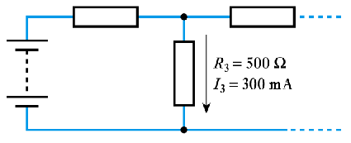

* 1. 150 mW
  2. 45 mW
  3. 150 W
  4. 45 W

1. Computers uses one of the following for internal data representations
   1. binary numbers
   2. octal numbers
   3. decimal numbers
   4. hexadecimal numbers
2. What are the names of the bipolar transistor connections?
   1. Base, Collector & Source
   2. Gate, Collector & Emitter
   3. Emitter, Drain & Base
   4. Base, Emitter & Collector
3. What inputs are required to cause the output of a NOR gate to go high?
   1. A = 0, B = 0
   2. A = 1, B = 0
   3. A = 0, B = 1
   4. A = 1, B = 1
4. Boolean algebra is a mathematical system for manipulating input variables that can take
   1. Four possible values
   2. Two possible values
   3. Three possible values
   4. None of the above
5. Replace each variable by its complement and change all ANDs to ORs and all ORs to ANDs. This refers to
   1. DeMorgan’s law
   2. Absorption law
   3. Double complement law
   4. None of the above
6. Any two logically equivalent Boolean expressions
   1. are of same size
   2. have identical truth tables
   3. lead to build same digital computer circuit
   4. none of the above
7. What did the fourth computer generation use as typical hardware?
8. Transistors, Magnetic core memory
9. SSI/MSI ICs, Minicomputers
10. VLSI IC’s, Personal computers
11. Optical disks, Internet
12. What is the total resistance with the following four resistors in series; a 330 Ω resistor, 27 Ω resistor, a 390 kΩ resistor and a 4.7 kΩ resistor?
    1. 395 kΩ
    2. 5.45 kΩ
    3. 752 kΩ
    4. 25 Ω
13. What is the total resistance with the following four resistors in parallel, two 1 kΩ resistors and two 3.9 kΩ resistors?
    1. 1.59 kΩ
    2. 470 Ω
    3. 398 Ω
    4. 987 Ω
14. What is the power dissipated in a resistor when it has a volt drop of 12V, and has a current flowing through it of 30mA?
    1. 360 mW
    2. 360 W
    3. 400 W
    4. 2.5 mW
15. What is answer when you add 1101102 and 100112 together?
    1. 10011012
    2. 10110012
    3. 10010012
    4. 11010012
16. What is the answer when you multiple 101012 and 1012 together?
    1. 1111112
    2. 10010102
    3. 10101012
    4. 11010012
17. What is the base current?

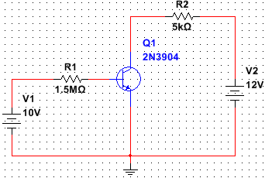

* 1. 6.7 µA
  2. 2.4 mA
  3. 6.2 µA
  4. 6.6 mA